**PROGRAM-1**

**HTML TABLES**

**AIM:**

Write an html program to display table as follows:

|  |  |  |
| --- | --- | --- |
|  | Average | |
| Height | Weight |
| Males | 2.1 | 0.003 |
| Females | 1.9 | 0.002 |

**Program**

<html>

<head>

<title>Html Table

</title>

</head>

<body>

<table border="2">

<tr>

<td rowspan="2"></td>

<td colspan="2">Average</td>

</tr>

<tr>

<td>height</td>

<td>weight</td>

</tr>

<tr>

<td>Male</td>

<td>2.1</td>

<td>0.003</td>

</tr>

<tr>

<td>Female</td>

<td>1.9</td>

<td>0.002</td>

</tr>

</table>

</body>

</html>

**Result**

The html program is displayed successfully.

**Output**

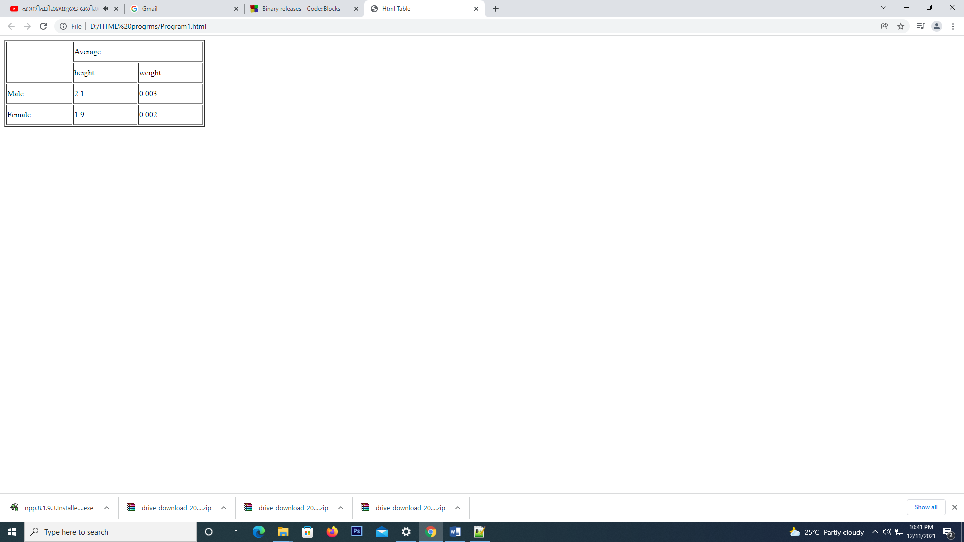

**PROGRAM-2**

**HTML LISTS**

**AIM:**

Write a program to create a list as follows:

Ordered list

1. Appetizers
2. Main Course
3. Salads

Unordered list

* Cold Drinks
* Hot Drinks
* Ice Cream

**Program**

<html>

<head>

<title>Html Lists

</title>

</head>

<body>

<p>Ordered List<p>

<ol type="1">

<li>Apppetizers</li>

<li>Main Course</li>

<li>Salads</li>

</ol>

<p>Unordered List<p>

<ul type="circle">

<li>Cold Drinks</li>

<li>Hot Drinks</li>

<li>Ice Cream</li>

</ul>

</body>

</html>

**Result**

The html program is displayed successfully.

**Output**

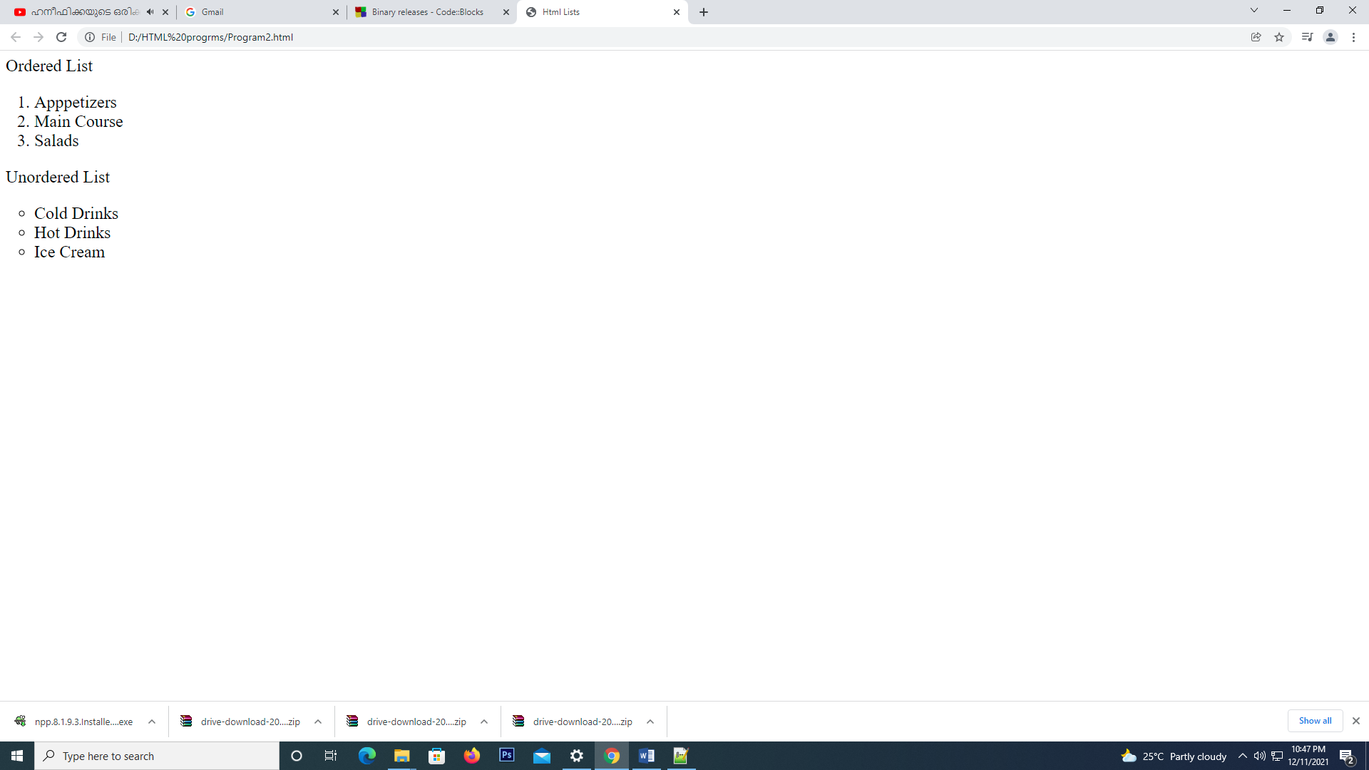

**PROGRAM-3**

**BASIC WEBSITE DESIGN OF A COLLEGE**

**AIM:**

Design a website of your college which contain home page, department and about us using html (Use image, tables and links)

**Program**

**collegesite.html**

<html>

<head>

<title>Amal Jyothi College</title>

</head>

<body>

<img src="homepage.png" height="100%" width="100%">

<p>AMAL JYOTHI COLLEGE</p>

<a href="collegesite.html" style="text-align:right;">Home</a>&nbsp;&nbsp;

<a href="aboutus.html" style="align:right;">About Us</a> &nbsp;&nbsp;

<a href="department.html" style="align:right;">Department</a>

</body>

</html>

**aboutus.html**

<html>

<head>

<title>Amal Jyothi College-About Us</title>

</head>

<body>

<h1 align="center">AMAL JYOTHI COLLEGE</h1>

<h3 align="center">ABOUT US</h3>

<p align ="justify">Amal Jyothi College of Engineering, Kanjirapally, is the first engineering college in Kerala to obtain NAAC accreditation with ‘A’ grade, and the first new generation engineering college in the State to secure the prestigious NBA accreditation for prime departments. The main features of the College comprise world-class infrastructure, top-flight faculty, high pass percentage, excellent placement record, unique student projects and first rate start-ups. </p>

<a href="collegesite.html">Home</a>&nbsp; &nbsp;

<a href="aboutus.html">About Us</a> &nbsp; &nbsp;

<a href="department.html">Department</a>

</body>

</html>

**department.html**

<html>

<head>

<title>Amal Jyothi College-Departments</title>

</head>

<body>

<h1 align="center">AMAL JYOTHI COLLEGE</h1>

<h3 align="center">Departments</h3>

<table border="2" align="center" height="500px" width="800px">

<tr>

<th>Departments</th>

<th>No. Of Seats</th>

<th>No. Of Students</th>

<th>Total Fees</th>

</tr>

<tr>

<td>MCA</td>

<td>120</td>

<td>114</td>

<td>1 Lakhs</td>

</tr>

<tr>

<td>MCA(Integratd)</td>

<td>60</td>

<td>60</td>

<td>2.5 Lakhs</td>

</tr>

<tr>

<td>MTECH</td>

<td>100</td>

<td>95</td>

<td>2 Lakhs</td>

</tr>

<tr>

<td>BTECH</td>

<td>250</td>

<td>242</td>

<td>2 Lakhs</td>

</tr>

</table>

<a href="collegesite.html">Home</a>&nbsp; &nbsp;

<a href="aboutus.html">About Us</a> &nbsp; &nbsp;

<a href="department.html">Department</a>

</body>

</html>

**Result**

The html program is displayed successfully.

**Output**

**collegesite.html**

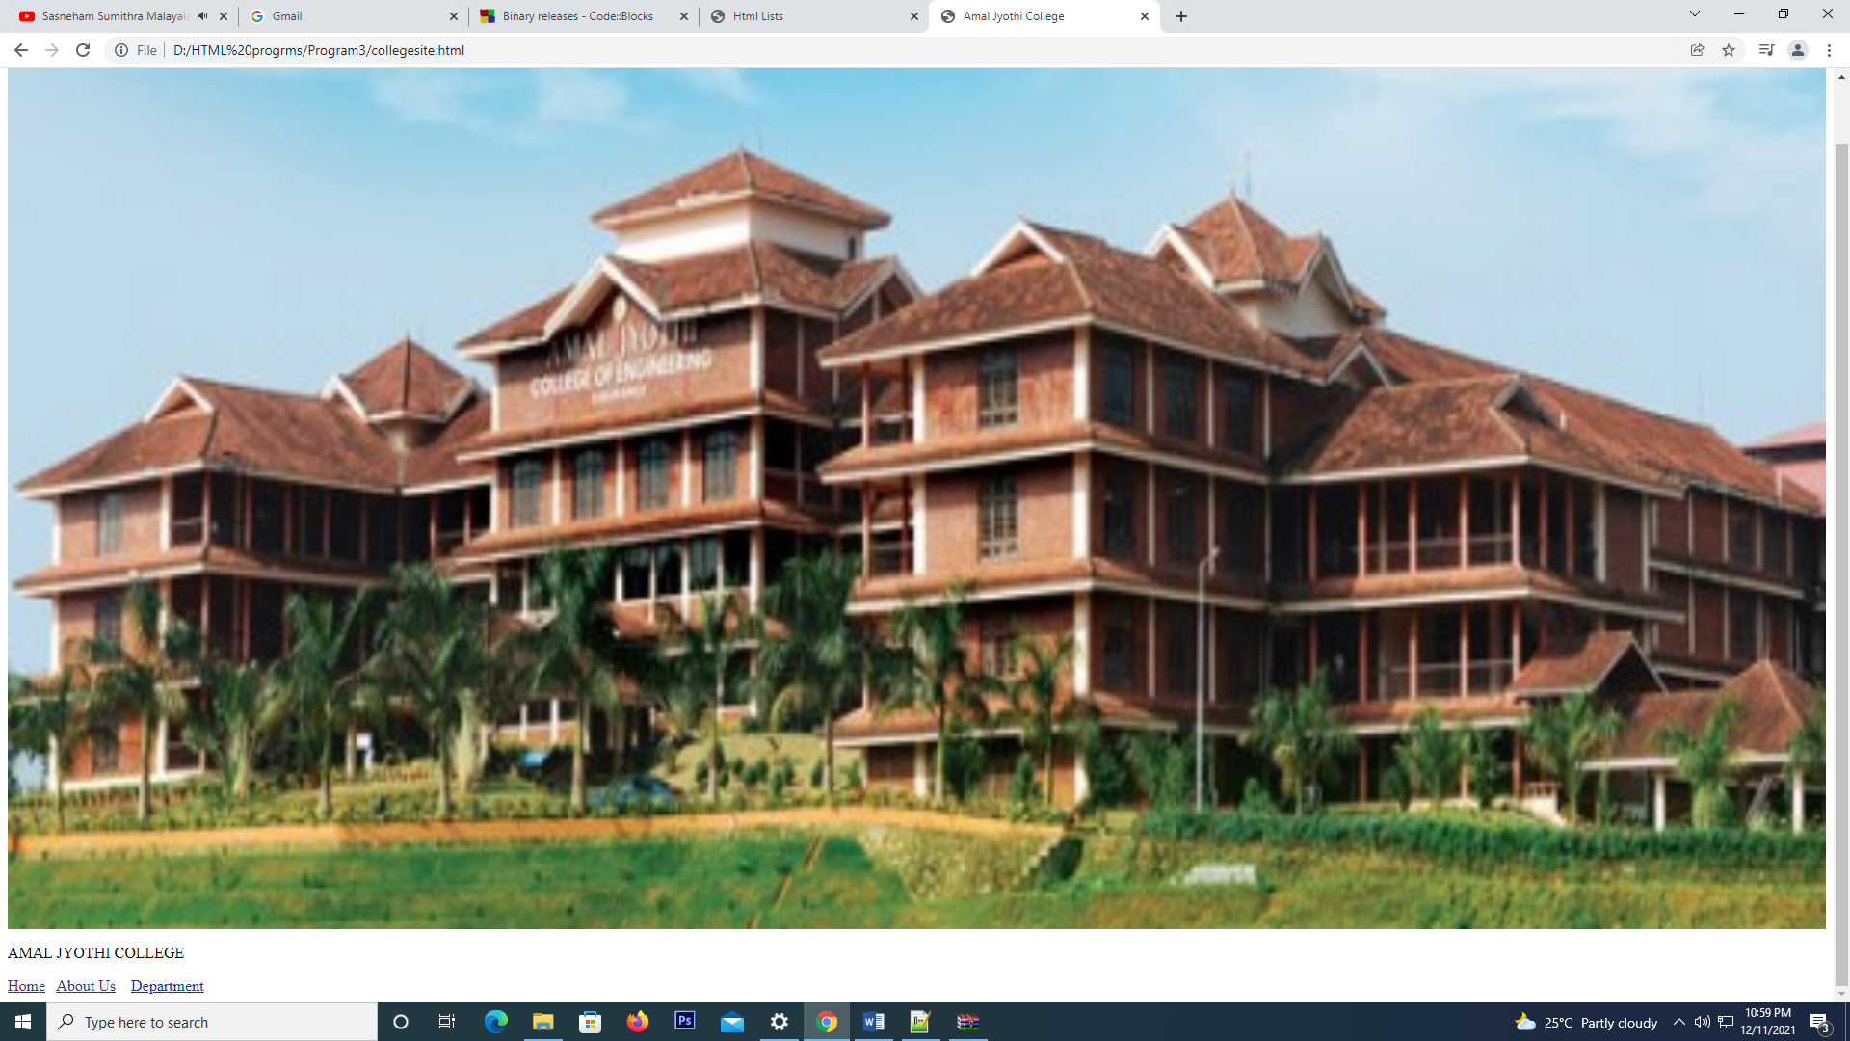

**aboutus.html**

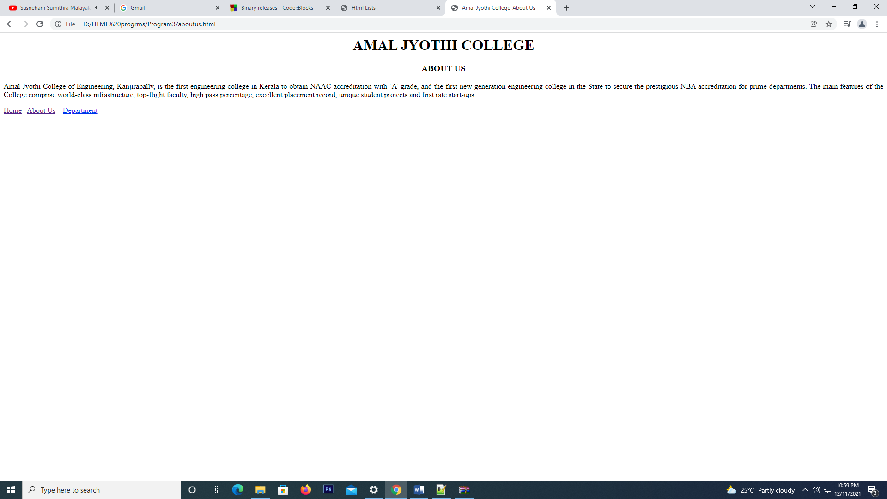

**department.html**

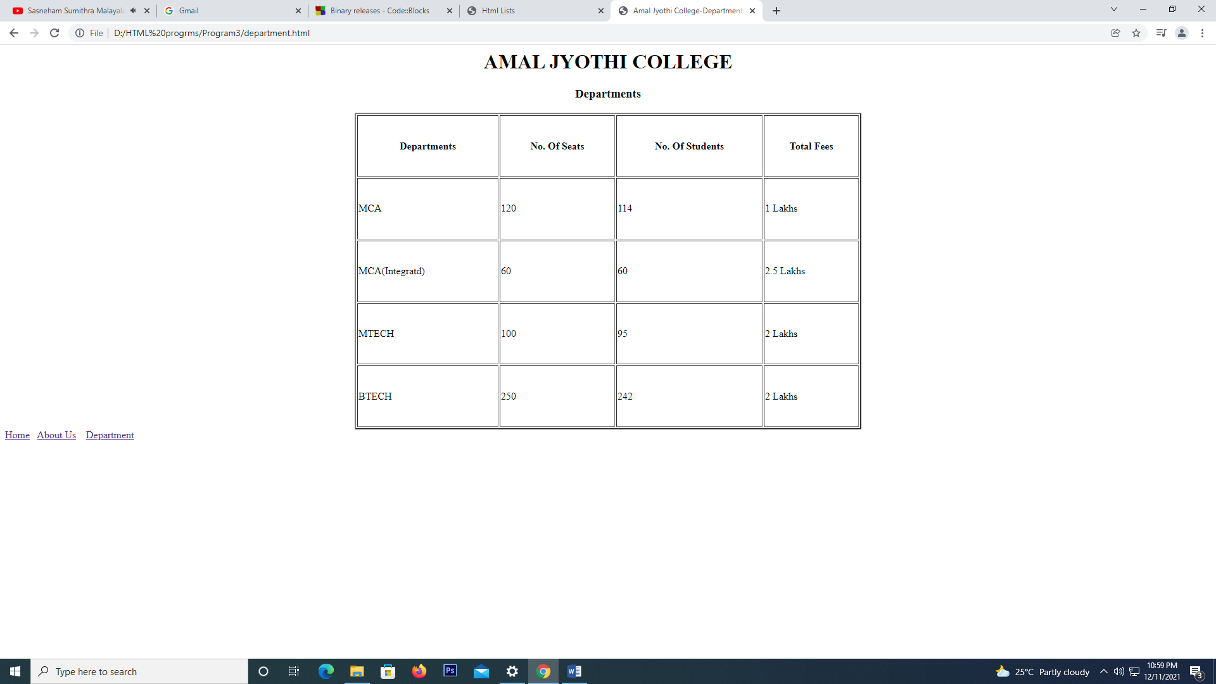

**PROGRAM-4**

**HTML REGISTRATION FORM**

**AIM:**

Demonstrate a registration form using html

**Program**

<html>

<head>

<title>Registration Form

</title>

</head>

<body>

<h1 align="center">AMAL JYOTHI COLLEGE</h1>

<h3 align="center">Student Registration Form</h3>

<form style="font-size:20px; text-align:justify;">

<label for="fname">First Name:</label>

<input type="text" name="fname" placeholder="Enter First Name" style="height:40px; width:500px;"> <br><br>

<label for="lname">Last Name:</label>

<input type="text" name="lname" placeholder="Enter Last Name" style="height:40px;width:500px;"> <br><br>

<label for="dob">Date Of Birth:</label>

<input type="date" name="dob" style="height:40px; width:475px;"> <br><br>

<label for="gender">Gender:</label>

<input type="radio" name="gender" value="male">&nbsp;

<label for="male">Male</label>&nbsp; &nbsp;

<input type="radio" name="gender" value="female">&nbsp;

<label for="female">Female</label>&nbsp; &nbsp;

<input type="radio" name="gender" value="others">&nbsp;

<label for="others">Others</label><br><br>

<label for="qualification">Educational Qualification:</label>

<select name="qualification" style="height:40px; width:380px;">

<option value="sslc">SSLC</option>

<option value="plustwo">Plus Two</option>

<option value="graduation">Graduation</option>

<option value="post-graduation">Post Graduation</option>

</select><br><br>

<label for="address">Address:</label>

<textarea name="address" placeholder="Enter Address" style="height:100px; width:520px;">

</textarea><br><br>

<label for="phone">Mobile Number:</label>

<input type="text" name="phone" placeholder="Enter Mobile Number" style="height:40px; width:455px;"> <br><br>

<label for="email">Email id:</label>

<input type="email" name="email" placeholder="Enter Email ID" style="height:40px; width:515px;"> <br><br>

<label for="password">Password:</label>

<input type="password" name="password" placeholder="Enter a Password" style="height:40px; width:512px;"> <br><br>

<label for="cpassword"> Confirm Password:</label>

<input type="password" name="cpassword" placeholder="Confirm new Password" style="height:40px; width:440px;"><br><br>

<input type="submit" name="submit" style="height:50px; width:200px;">&nbsp;

<input type="reset" name="reset" style="height:50px; width:200px;">

</form>

</body>

</html>

**Result**

The html program is displayed successfully.

**Output**

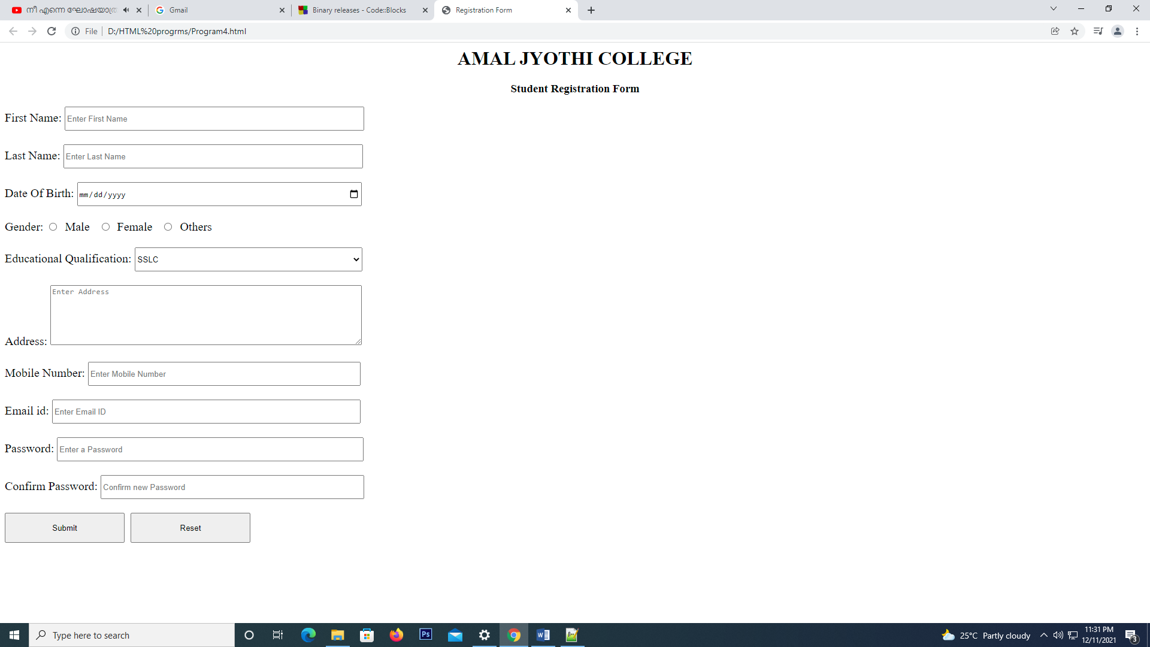

**PROGRAM-5**

**HTML REGISTRATION FORM**

**AIM:**

Create a html page with different types of frames such as Floating Frame(iframe), Navigation Frame and Mixed Frame (horizontal & vertical)

**Program**

**frameset.html**

<html>

<head>

<title>Html Frames</title>

</head>

<frameset cols="25%, *" scrolling="no" noresize>

<frame name="image1" src="navframe.html"></frame>

<frameset rows="50%, *" scrolling="no" noresize>

<frame name="image2" src="iframe.html"></frame>

<frame name="image3" src="mixedframe.html"></frame>

</frameset>

</frameset>

</html>

**iframe.html**

<html>

<head>

<title>Html Iframes</title>

</head>

<body>

<h1>W3 SCHOOLS HTML TUTORIAL</h1>

<iframe src="https://www.w3schools.com/html/" name="image3" src="" height="50%" width="70%"> </iframe>

</body>

</html>

**mixedframe.html**

<html>

<head>

<title>Html Mixed Frames</title>

</head>

<body>

<h1>HTML MIXED FRAMES</h1>

<img src="image1.png" height="100%" width="100%"/>

</body>

</html>

**navframe.html**

<html>

<head>

<title>Html Navigation Frames</title>

</head>

<body>

<h1>HTML NAVIGATION FRAMES</h1>

<a href="navframe.html">Navigation Frame</a><br><br>

<a href="iframe.html">Floating Frame</a><br><br>

<a href="mixedframe.html">Mixed Frame</a>

</body>

</html>

**Result**

The html program is displayed successfully.

**Output**

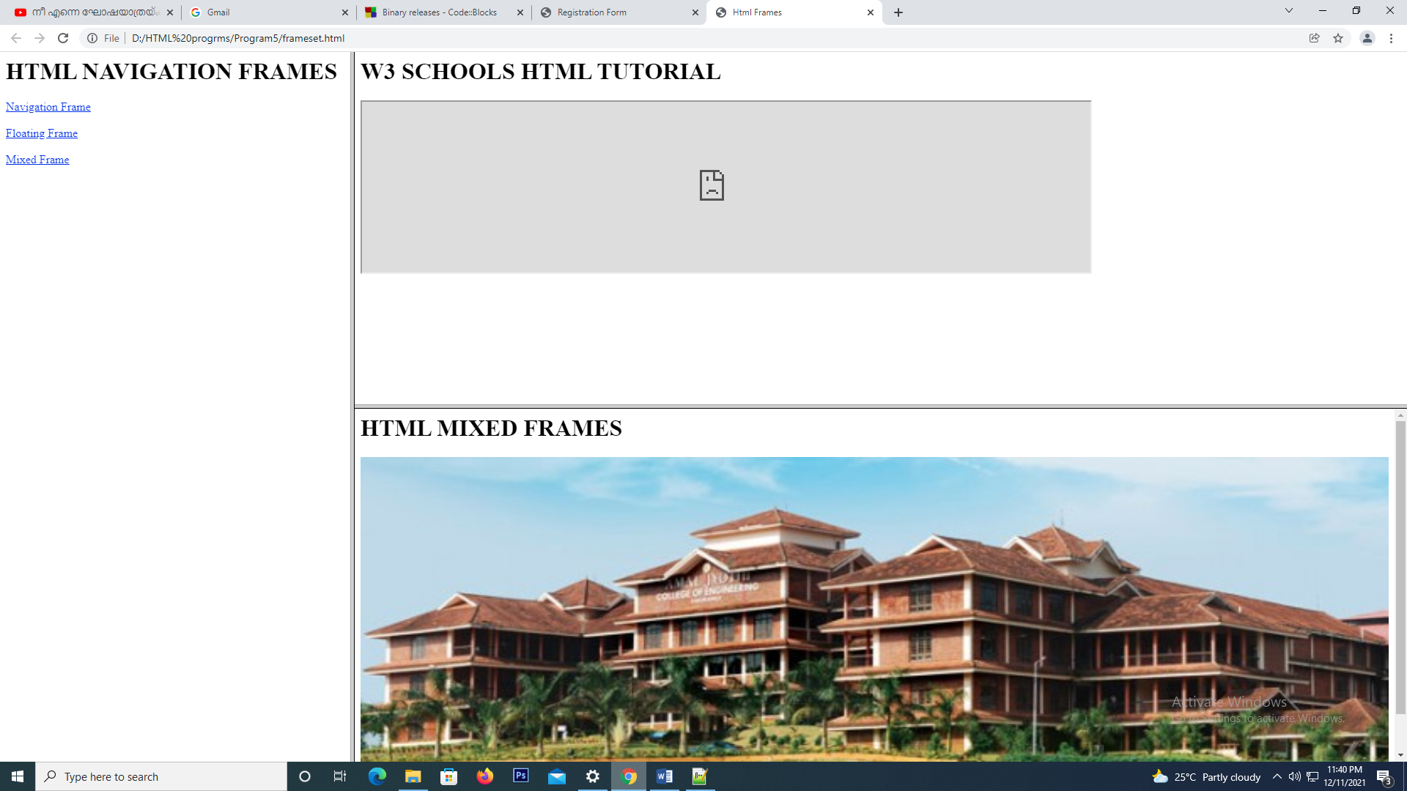

**PROGRAM-6**

**HTML BIODATA**

**AIM:**

Write an html program to create biodata of a student

**Program**

**Style.css**

h1{

color:red;

text-align:center;

font-family:Algerian;

}

h2{

color: #ff9900;

font-size:20px;

text-align:center;

background-color: #80ffff;

}

table {

width:150px;

height:10px;

margin-left:10px;

}

table, th, td {

border: 1px solid lightblue;

}

**Program6.html**

<html>

<head>

<title>HTML BIODATA</title>

<link rel="stylesheet" type="text/css" href="style.css">

<style>

p {

font-size:16px;

margin-left:10px;

}

</style>

</head>

<body>

<div style="border:2px solid blue;">

<h1>BIODATA</h1>

<div>

<h2>PERSONAL DETAILS</h2>

<p>Name: &nbsp; Alan Varghese<br>

Gender: &nbsp; MALE<br>

Address: &nbsp; KAnjirakombil(H), melattur, Pathirikode P.O ,<br> &nbsp;&nbsp;&nbsp;&nbsp;&nbsp;

&nbsp; &nbsp; &nbsp; &nbsp;&nbsp;&nbsp;&nbsp;&nbsp;&nbsp;&nbsp;&nbsp;Perinthalmanna,malappuram<br>

Email Id: &nbsp; alanvarghese2023a@mca.aje.in<br>

Mobile No.: &nbsp; 9207855783

</p>

</div>

<div>

<h2>EDUCATIONAL QUALIFICATION</h2>

<table>

<tr>

<th>Sl No.</th>

<th>Qualification</th>

<th>Institution</th>

<th>Marks/Grades</th>

</tr>

<tr>

<td>1. </td>

<td>TENTH</td>

<td>ASMH SCHOOL</td>

<td>80%</td>

</tr>

<tr>

<td>2. </td>

<td>TWELTH</td>

<td>ASMHS SCHOOL</td>

<td>70%</td>

</tr>

<tr>

<td>3. </td>

<td>DEGREE: BCA</td>

<td>St.Mary’s COLLEGE</td>

<td>64%</td>

</tr>

</table>

</div>

<div>

<h2>HOBBIES</h2>

<ul type="circle">

<li>badminton</li>

<li>travel</li>

</ul>

</div>

</div>

</body>

</html>

**Result**

The html program is displayed successfully.

**Output**

